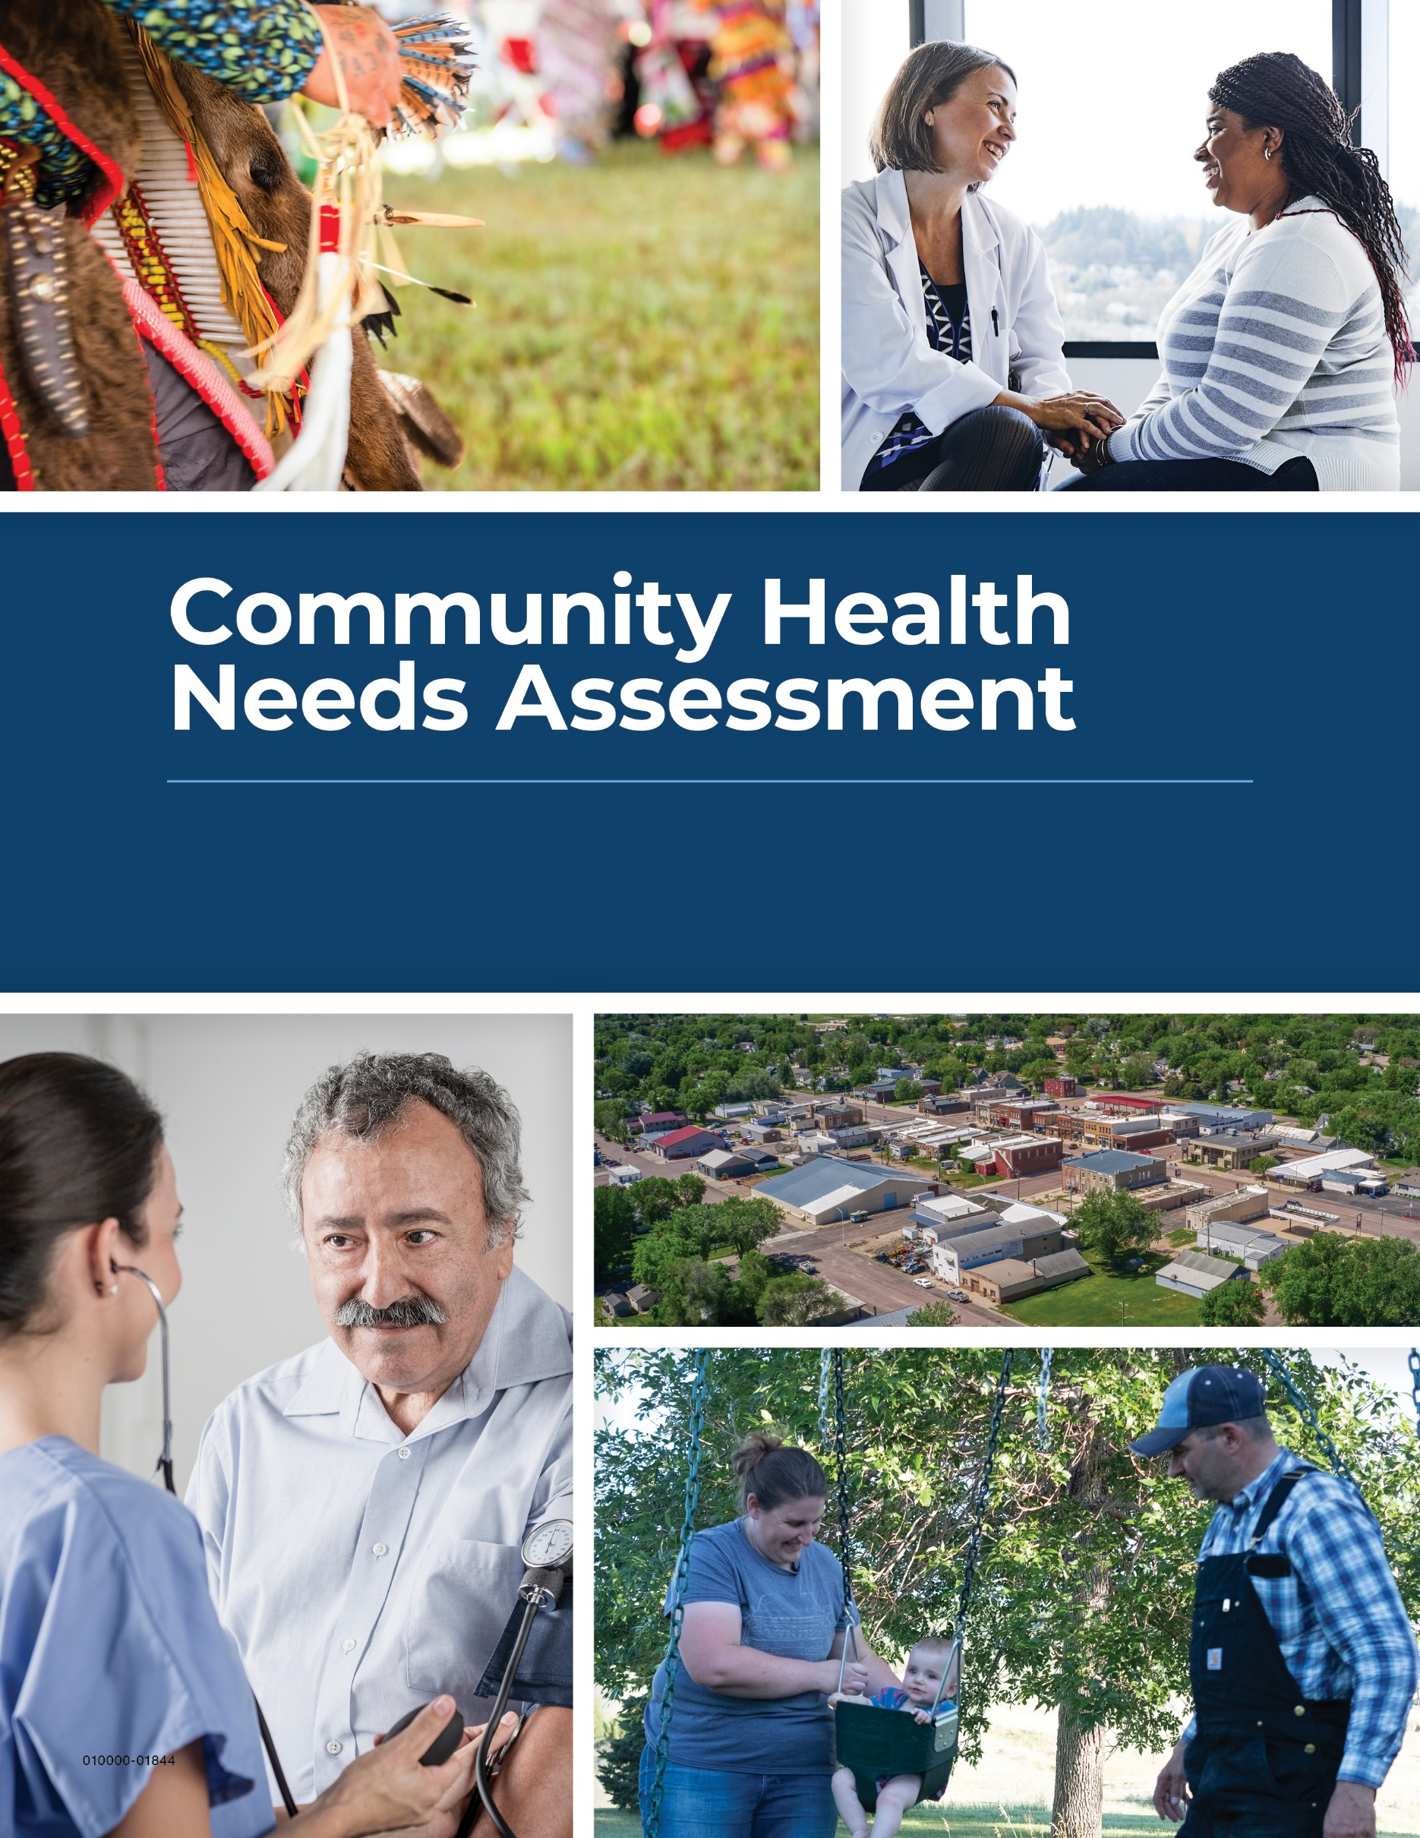

Winner REgional Health
2026-2028

Dear Community Members,

Winner Regional Health is pleased to present the 2025 Community Health Needs Assessment (CHNA). We complete a community health needs assessment every three years. The assessment identifies health needs in the community and enables us to address those needs.

Earlier this year, members of the community were invited to complete a survey to help identify unmet health needs across a range of social determinants of health. These include economic well-being, transportation, children and youth, the aging population, safety, access to services, and mental/behavioral health.

Sanford Health provided support for the CHNA process, including analysis of the data from the primary survey research and key secondary data points, along with leading a facilitated discussion with key stakeholders in the community to help prioritize the identified health needs.

After completing this year’s assessment, Winner Regional Health will address the following health needs in a formalized implementation strategy for 2026-2028:

• Access to Daily Transportation
• Access to Health Care Providers and Quality Care

The CHNA process also highlights the many strengths, support, and resources available to residents of our community. This report includes an overview of the community assets offered to address various community health needs. Additionally, we have included an impact report detailing progress made to date with implementation strategies from the previous assessment.

Our team is truly grateful to the community members who participated in this year’s assessment process. We appreciate your commitment to the health and wellness of our community. We look forward to collaborating with community partners to continue to improve the quality of life for all.

Sincerely,

Brian Williams
Chief Executive Officer
Winner Regional Health
Winner, SD
BACKGROUND

Community Description
Winner is located in south central South Dakota along Highways 18, 183 and 44 and is the county seat of Tripp County. The population of Winner is 2,921 and the city covers approximately 922.5 acres of land. Winner was part of the famous Louisiana Purchase of 1803 and later part of the Dakota Territory, established by an act of Congress and a proclamation by President Abraham Lincoln in 1861.

Winner was so named because it was the “winner” in the struggle to establish a town along the railroad right-of-way when the Chicago North Western began moving west from Dallas, SD in 1909. Over 300 businesses are active in Winner. The Winner School District is rated level 1 by the South Dakota Division of Education, with the high school accredited by the North Central Association of Colleges and High Schools.

Winner is home to a regional health care center and two modern assisted living centers. Recent capital improvements in the city include a new main street, new runway at the airport, and a new fire hall/ambulance facility with a new training room.

The community as defined for purposes of the Community Health Needs Assessment includes Tripp County, SD. Demographic detail for the county is included in the appendix.

Partners
The Community Health Needs Assessment builds on the work of previous cycles and is the result of the coordinated efforts of many internal and external partners. Sanford Health would like to thank and acknowledge the following and their teams for their assistance. This program would not be possible without their expertise.

Community Partners
We express our gratitude to the following community collaborative members for their expertise during the planning, development and analysis of the community health needs assessment:
- Jeremy Clay, City Councilman
- Mitch Miller, Public Safety Commissioner
- Lana Stickland,
- Shana Hakus, Community Resource Center
- Amanda Seosbe, CFO Winner Regional Health
- Mindi Miller, CNO, Winner Regional Health

Sanford Health
- Erika Batcheller, Executive Vice President, Chief External Affairs Officer
- Nick Olson, Executive Vice President, Chief Financial Officer
- Corey Brown, Senior Vice President, Government Affairs
- Amber Langner, Senior Vice President, Treasury
- Blayne Hagen, Vice President, General Counsel, Sioux Falls
- Lindsay Daniels, Vice President, Care Management
- Doug Nowak, Vice President, Data Analytics
- Natasha Smith, Head of Diversity, Equity and Inclusion
- Catherine Bernard, Director, Tax
- Karla Cazer, Clinical Nurse Specialist, Faith Community Nursing Center
- Deana Caron, Senior Tax Accountant
- Kurt Brost, Senior Director, Community Relations
- David Hill, Director, Chief Privacy Officer
- Jessica Sexe, Senior Director, Communications
- Phil Clark, Director, Marketing Insights
- Shawn Tronier, Lead Marketing Analyst
- Chase Gerar, Strategic Planning Advisor, Fargo
- Brian Ritter, Head of Market Affairs, Bismarck
- Kayla Winkler, Lead Community Relations Specialist, Bemidji

Regional Partners
- Sister Nancy Miller, Director Mission Integration, CHI St. Alexius Health
- Julie Ward, VP of Diversity, Equity & Inclusion, Avera McKennan Hospital & University Health Center
- Angela Schoeffelman, Community Program Manager, Avera Community Health Resource Center
- Alli Fast, Community Health Program Manager, Essentia Health
- Nancy Hodur, Director, North Dakota State University Center for Social Research
- Karen Olson, Research Specialist, North Dakota State University Center for Social Research
- Kathy McKay, Public Health Administrator, Clay County Public Health
- Desi Fleming, Director of Public Health, Fargo Cass Public Health
- Justin Bohrer, Public Health Analyst & Operational Planning Lead, Fargo Cass Public Health
- Julie Sorby Engen, Director of Community Development, Family HealthCare
- Shelby Kommes, Public Health Coordinator, Sioux Falls Health Department
- Renae Moch, Public Health Director, Bismarck-Burleigh Public Health and Immediate Past President, North Dakota Public Health Association
- Erin Ourada, Administrator, Western Plains Public Health
- Joe Kippley, Public Health Director, Sioux Falls

Winner Regional Health Description
Winner Regional Health is a 25-bed Critical Access Hospital and 40-bed long-term care facility that caters to the health needs of south central South Dakota and north central Nebraska. Physicians in the following specialties provide consultation and treatment at Winner Regional Health's Outreach Clinic:
- Audiology
- Bone Density Scan
- Cardiology
- Diabetic Education
- Dietician
- Digital Mammography
- Lactation Consultant
- MRI
- Neurology
- Nephrology
- OB/GYN
- Oral Sedation
- Outpatient chemotherapy
- Podiatry
- Pulmonology
- Retail Pharmacy (Winner Regional Health Pharmacy)
- Speech Therapy
- Urology
- Vascular
Winner Regional Health is a not-for-profit facility that operates for the benefit of patients and residents in our service area. The nine-person volunteer Board of Directors manages the operation of our institution. The board chooses three candidates from our local communities each year to serve three-year terms on the board.

Our management agreement with Sanford Health aids the hospital and long-term care facility with purchasing, training, technology, and administration. Winner Regional is dedicated to providing quality employment opportunities and purchasing local goods whenever possible.

CHNA Purpose
The purpose of a community health needs assessment is to develop a global view of the population's health and the prevalence of disease and health issues. Findings from the assessment serve as a catalyst to align expertise and develop a Community Investment/Community Benefit plan of action. There is great intrinsic value in a community health needs assessment when it serves to validate not-for-profit status and create opportunity to identify and address public health issues from a broad perspective. A community health needs assessment identifies the community’s strengths and areas for improvement. A community health needs assessment is critical to a vital Community Investment/Community Benefit Program that builds on community assets, promotes collaboration, improves community health, and promotes innovation and research. It also serves to support progress made toward organizational strategies.

Regulatory Requirements
Federal regulations stipulate that non-profit medical centers conduct a community health needs assessment at least once every three years and prioritize the needs for the purpose of
implementation strategy development and submission in accordance with the Internal Revenue Code 501(r)(3).

The Internal Revenue Code 501(r) requires that each hospital must have: (1) conducted a community health needs assessment in the applicable taxable year or in either of the two immediately preceding taxable years; (2) adopted an implementation strategy for meeting the community health needs identified in the assessment; and (3) created transparency by making the information widely available.

The regulations stipulate that each medical center take into account input from persons who represent the broad interests of the community. Hospitals are required to seek input from at least one state, local, tribal or regional government public health department or state Office of Rural Health, with knowledge, information or expertise relevant to the health needs of the community.

Non-profit hospitals are also required to seek input from members of medically underserved, low income, and minority populations in the community, or organizations serving or representing the interest of such populations. This includes underserved populations experiencing disparities or at risk of not receiving adequate care due to being uninsured or due to geographic, language or financial or other barriers.

The community health needs assessment includes a process to identify community resources available to address identified and prioritized needs. Hospitals are to address each assessed need or explain why they are not addressing a need. Once needs have been identified and prioritized, hospitals are required to develop an implementation strategy for each. The strategies are reported on the IRS 990 and a status report must be provided each year on IRS form 990 Schedule H.

Finally, hospitals are required to be transparent with the findings and make the written CHNA report available to anyone who requests it. All CHNA reports and
implementation strategies are housed on the hospital’s website at www.winneregional.org. Hospitals must keep three cycles of assessments on their website.

Winner Regional Health extended a good faith effort to engage all aforementioned community representatives in this process. We worked closely with public health experts throughout the entire assessment process. Public comments and responses to the community health needs assessment and the implementation strategies are welcome on the organization’s website or via email/phone at <<insert>>. No community comments or questions regarding the previous CHNA have been made via the website link or email address.

CHNA Process
Winner Regional Health worked with Sanford Health to utilize a process developed in coordination with public health experts, community leaders, and other health care providers, within the local community and across South Dakota, North Dakota, and Minnesota to develop a multi-faceted assessment program designed to establish multiple pathways for health needs assessment.

Limitations
The findings in this study provide an overall snapshot of behaviors, attitudes, and perceptions of residents living in the community. A good faith effort was made to secure input from a broad base of the community. However, gaps in individual data sources may arise when comparing certain demographic characteristics (i.e., age, gender, income, minority status) with the current population estimates. For example, these gaps may occur due to the difficulty in reaching respondents through the survey process.

To mitigate limitations, the CHNA evaluates community health from several perspectives: a
stakeholder and community survey, meetings with community leaders that have special knowledge and expertise regarding populations, secondary data sources such as the U.S. Census Bureau and County Health Rankings, public comments from previous assessments, and institutional knowledge by employees.

Community and Stakeholder Survey
Community residents were asked a series of questions through an online survey designed in partnership with health experts and public health officials across the Sanford footprint to understand health needs. Survey design is based on the UW Population Health Institute model. Each respondent was asked to rate community drivers from poor to excellent. Any response other than excellent was offered a follow-up opportunity to comment on the reason for their ranking. Respondents were also asked a series of questions specific to their health care access, health care quality, barriers to care, travel to care, and insurance. The survey was sent to a sample of the Tripp County, SD, population secured through Qualtrics, a qualified vendor. The full set of questions is available in the appendix.

The survey was the first of multiple efforts to engage community stakeholders and elected officials with knowledge and connections amongst medically underserved, low income, or minority populations. Stakeholders were sent the survey and asked to complete the instrument and then forward the survey to their respective populations for greater involvement.

Survey data for the local community should be considered directional and best utilized in conjunction with additional data. A total of 282 respondents from the CHNA area completed the survey. The data was augmented for analysis with responses from other hospitals participating in the CHNA process during the same period.
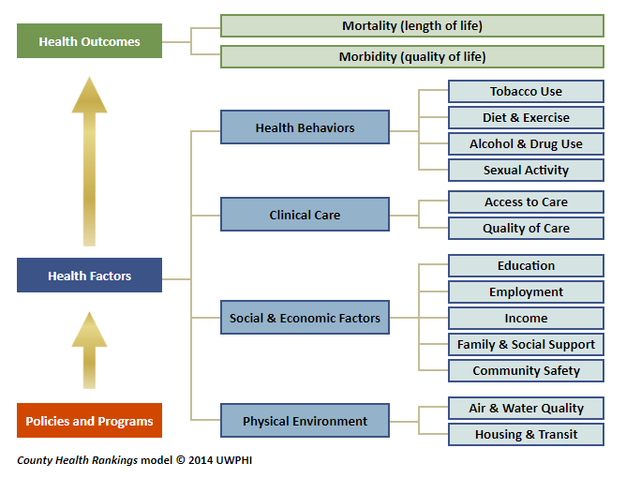
Secondary Data
County Health Rankings are based upon the UW Population Health model and serve as the main secondary data source utilized for the community health needs assessment. Alignment of the survey and secondary data within the UW Population Health model allows for greater connection of the data sets. Population data are sourced to the U.S. Census Bureau. Additional data sources may be used and are sourced within the document.

Health Needs Identification Methodology
The Center for Social Research at North Dakota State University was retained to develop the initial community health needs list for each community, building upon their involvement during the previous cycle. The following methodology was used to develop the significant health needs presented later in the report:
- To identify community health care needs, the community’s score by question was compared to the average stratified composite of a comparative group that completed the survey in other communities within the region, including Murray County and Big Stone County, MN, and Turner, and Gregory counties in South Dakota.
- To identify community health care needs, each community’s score by question was compared to the average stratified composite of the comparative group. For example, if the composite stratified system-wide average score is 4 and an individual community’s average response was 2.5, which would suggest an issue of concern and a potential community health care need to be highlighted in the summary findings.
- Upon determination of a potential strength or need, County Health Rankings (https://www.countyhealthrankings.org/) and responses from open-ended questions provided additional insights into the drivers of the respective needs.
- A similar methodology was also used to provide additional insights into findings from County Health Rankings data with relevant health needs highlighted in the survey findings.
- Health needs identified through either the survey or County Health Rankings data but not both were also included in the findings.
- The Center for Social Research validates the findings of the primary research by engaging at least two internal reviewers. Each reviewer has their own technique and strengths to review the findings; however, they check for accuracy in the data by reviewing the code/syntax, the output, the correct representation of the data in the report, verbiage, consistency, context, and overall readability. Both reviewers also supported previous CHNA reports.

Community Asset Mapping
Asset mapping was conducted to locate community resources available to address the assessed needs. Each unmet need was researched to determine what local resources are available. Once gaps were determined, the prioritization exercise followed with key stakeholder groups determining top needs for their community.

Community Stakeholder Meetings
Community stakeholders and elected officials with knowledge and connections amongst medically underserved, low income, or minority populations were further included in the process during the community stakeholder meetings. During the meetings, survey findings were presented to community stakeholders. Facilitated discussion commenced and each participant was asked to consider the needs identified that should be further developed into implementation strategies. Health needs identified during the previous cycle but not raised through the survey or County Health Rankings were also considered. The meeting served to inform the group of the findings but also served as a catalyst to drive collaboration and prioritization of local needs.

The participants provided information to answer the following types of questions as it relates to identified needs:
- What are the biggest challenges currently with these needs in the community?
- Does the community have gaps in services, access, outreach, etc.?
- What opportunities exist, where can we have greatest impact in addressing these needs?
- Which are most urgent in nature?
- Is there already work being done on these needs?
- What are the resources currently not utilized within the community that could address this topic?
- Which needs fall within the purview of health care system and which do not? Can the non-healthcare needs be shared with other entities or organizations?
- Is there anything you consider an urgent need that we have not discussed?

Following the meeting the hospital administrator and staff identified the specific health needs to be addressed within the Implementation Plan. Administrator recommendations are based on all factors, including primary and secondary data, input from the community stakeholder meeting, and scalability of current hospital programs and resources to address the identified needs efficiently and effectively. All identified needs not addressed in the implementation plan were shared with other community partners for action.

COMMUNITY HEALTH NEEDS ASSESSMENT FINDINGS

Winner Regional Healthcare Center in Winner, SD is an independent facility that contracts with Sanford Health for certain services, including support for the Community Health Needs Assessment. Winner Regional Healthcare Center completes a community health needs assessment (CHNA) every three years to assist in identifying unmet health needs in the community, and then strategically plans how to best address those needs. As part of this effort, from February through May 2025, residents of the Winner Regional Healthcare Center market area were invited to complete an online community survey to help identify unmet health needs across a range of social determinants of health. Winner Regional Healthcare Center, Sanford Health, and the NDSU Center for Social Research partnered to analyze data from the primary survey research along with key secondary data points as part of the CHNA process.
For the purposes of this assessment, the Winner Regional Healthcare Center (WRHC) market area is defined as Tripp County in South Dakota. The community health outcomes and health needs presented below were identified through a mix of primary and secondary research. Priority was given to the key topics rated lowest by respondents of the community survey, with further analysis provided through secondary research using the 2025 County Health Rankings & Roadmaps (CHR) data. Areas of focus that may not have been raised by the community survey but shown to be an area of focus through secondary research are also included.
Community survey and CHR data were also collected for four similar-sized market areas served by facilities participating in the 2025 CHNA process. Data from all five communities were included in this analysis to further assist in identifying community health needs for the WRHC. The similar-sized market areas identified for and included in this analysis include those served by the Community Memorial Hospital in Burke, SD; Pioneer Memorial Hospital & Health Services in Viborg, SD; Ortonville Area Health Services in Ortonville, MN; and the Murray County Medical Center in Slayton, MN. Results were analyzed for each of the five market areas individually and for the group as a whole for comparison purposes.
A total of 282 respondents from the WRHC area completed the survey.

Community Health Outcomes
Survey respondents were asked to rate various issues impacting health in their community and issues impacting their personal health and wellness on the following 1 to 5 scale: 1=poor, 2=fair, 3=good, 4=very good, 5=excellent.

Overall, perceptions among survey respondents in the WRHC market area regarding the following community health issues were positive (average score of 3.00 or higher):
- Environmental health (average score=3.85)
- Community safety (average score=3.48)
- Access to exercise opportunities (average score=3.21)
- Quality early child care (average score=3.02)

In contrast, perceptions among survey respondents in the WRHC market area regarding the following community health issues were less than positive (average score of less than 3.00):
- Access to healthy foods (average score=2.95)
- Quality of health care (average score=2.88)
- Access to daily transportation (average score=2.77)
- Employment and economic opportunities (average score=2.69)
- Quality of long-term care, nursing homes, and senior housing services (average score=2.42)
- Affordable housing (average score=1.98)

When asked about their personal health, survey respondents in the WRHC area rated their current health and wellness as good (average score=3.37) and their current ability to access health care services as good (average score=3.02); however, both scores were the lowest average scores when compared to similar-sized markets.

CHR data indicate that Tripp County fares worse than the average county in South Dakota for personal health and well-being and for community health conditions. The following areas of concern were identified for further discussion (in no particular order).
Identified Health Needs
Access to Providers and Quality Health Care
Despite survey respondents in the WRHC area rating their own ability to access health care as good (average score=3.02), when they were asked about the most important health care issues impacting their community, access to health care services and providers was the top issue followed by quality health care. And respondents rated the overall quality of health care in their community as less than good (average score=2.88); a score which is the lowest when compared to similar markets.
While most respondents in the WRHC area have a primary care provider (86%), one in five respondents have not seen a provider for a routine checkup or screening in the past year. For the 22 percent of respondents who indicated that they or a family member did not receive needed medical care in the past year (which is the highest rate when compared to similar-sized markets), long wait times, inconvenient hours, a lack of providers, and not feeling welcome were cited as top reasons, followed by cost and the inability to pay. In addition, nearly all survey respondents in the WRHC area reported traveling outside of their community to receive health care services in the past three years (90%). When asked why, most of those who traveled for care indicated that they needed specialty care or the needed services were not available locally (86%), followed by 34 percent who were referred by a physician and 30 percent who sought better or higher quality care elsewhere.
CHR data indicate that when compared to similar-sized markets, the WRHC area has lower/better than average ratios of population to providers, with 1,114 people for every primary care physician, 928 people per dentist, and 234 people per mental health care provider. Despite this coverage, CHR data also indicate that when compared to similar-sized markets, the WRHC area has the highest rate of preventable hospital stays among Medicare enrollees (5,510 hospital stays per 100,000 people enrolled in Medicare might have been prevented by outpatient treatment), the lowest mammography screening rate (36%), and the lowest flu vaccination rate (18%).
When the 30 percent of respondents who rated their own ability to access health care as poor or fair were asked to explain why they did so, responses focused on a lack of providers in general as well as a lack of specialty care in their community. The vast majority of survey respondents in the WRHC area indicated that there are health care services they would like to see offered or improved in their community (82%). When these respondents were asked which health care services they would like to see offered or improved, most said labor and delivery (85%), followed by walk-in/urgent care (53%), OBGYN/women’s care (49%), family medicine/primary care (32%), dermatology (29%), cancer care (29%), long term care/nursing homes (27%), pediatrics/children’s care (23%), behavioral and mental health services (23%), general surgery (21%), and heart care (20%).

During the stakeholder meeting, participants acknowledged that access to services has been a challenge, particularly over the past year. The hospital shared that they are actively recruiting for multiple roles to help address this issue. While the county’s provider-to-resident ratios may align with state averages in areas like mental health, there was consensus that additional access is still needed. Home health services continue to offer a valuable option for residents with mobility or transportation barriers but staffing shortages and referral requirements have make it difficult to fully leverage this resource.

Local Asset Mapping
Insurance Resources:  - SD DHS Prescription Assistance Program: 605-773-3656  - The Insurance Center: 605-842-3260  - Southern Dakota Insurance Agency: 605-775-2097  - SD Medicaid / DSS: 800-305-3064  - American Family: 605-842-8300  - Dakota Care: 605-842-3260  - Bank West: 605-842-3004  - First Fidelity: 605-842-3811  - State Farm: 605-842-0470 | Health Care Resources:  - Winner Regional Health: 605-842-7100  - Southern Plains Behavioral Health  Services: 605-842-1465  - National Suicide Prevention Hotline: 800-273-8255 or dial 988  - NAMI of South Dakota: 605-271-1871  - SD Helpline Center: 211  - Community Connections: 605-842-1708

Access to Affordable Health Care
Cost and the ability to afford needed health care was identified as one of the top health care concerns that survey respondents and their families in the WRHC area face on a regular basis. In addition, for the 22 percent of respondents who indicated that they have not had a routine checkup or screening in the past year (which is the highest rate when compared to similar-sized markets), cost and the inability to pay for health care services was cited as one of the top reasons, behind long wait times and inconvenient hours.
Most people need some form of medical care in their lives and having health insurance helps to cover those medical costs. In fact, research has shown that having health coverage is associated with better health-related outcomes. In the WRHC market area, 16 percent of people have no health insurance coverage, which is the highest rate when compared to similar-sized markets.
Adding to the difficulty in accessing affordable health care in the WRHC area is the economic climate. Survey respondents in the WRHC area rated the employment and economic opportunities in their community as less than good (average score=2.69); a score which is the lowest when compared to similar markets). CHR data indicate that the WRHC market area has the highest child poverty rate (21%), one of the lowest median household incomes ($58,195), and the highest percentage of people with limited access to healthy foods (12% of people have low income and do not live near a grocery store) when compared to similar-sized markets. These economic challenges can be heightened for single-parent families which tend to have fewer resources, time, income, and flexibility – and CHR data indicate that 22 percent of children in the WRHC area live in a household headed by a single parent (the highest percentage among similar-sized markets).

Affordability challenges extend beyond healthcare into other areas of daily life. Stakeholder meeting participants highlighted rising costs of care and health insurance, compounded by increases in rent, mortgage payments, and food expenses, all contributing to greater financial strain for residents. The hospital does offer resources for individuals in need of financial support, including uncompensated care, to help ease some of these burdens.
Local Asset Mapping
Insurance Resources:  - SD DHS Prescription Assistance Program: 605-773-3656  - The Insurance Center: 605-842-3260  - Southern Dakota Insurance Agency: 605-775-2097  - SD Medicaid / DSS: 800-305-3064  - American Family: 605-842-8300  - Dakota Care: 605-842-3260  - Bank West: 605-842-3004  - First Fidelity: 605-842-3811  - State Farm: 605-842-0470 | Health Care Resources:  - Winner Regional Health: 605-842-7100  - Southern Plains Behavioral Health  Services: 605-842-1465  - National Suicide Prevention Hotline: 800-273-8255 or dial 988  - NAMI of South Dakota: 605-271-1871  - SD Helpline Center: 211  - Community Connections: 605-842-1708

Healthy Living
Certain areas of the country, particularly tribal lands and surrounding communities such as those in the WRHC market area, have long experienced lower health status when compared with other parts of the country. Disparities in health outcomes, as a result of systems, policies, and social and personal factors are prevalent.

Survey respondents in the WRHC area rated their own personal health and wellness as good (average score=3.37); however, this is the lowest average score when compared to similar-sized markets. Respondents also rated access to physical activity and exercise opportunities in their community as good (average score=3.21); however, this is also the lowest average score when compared to similar-sized markets. In addition, survey respondents rated access to healthy and nutritional foods in their community as slightly less than good (average score=2.95).
When survey respondents in the WRHC area were asked about their biggest health care concerns for themselves and their family (concerns they face on a regular basis), chronic health issues were among the top concerns along with affordability and access to health care providers. The most commonly cited chronic health concerns included viral illnesses, diabetes, and obesity/weight.
According to CHR data, one in five adults in the WRHC area consider themselves to be in fair or poor health (19%), which is the highest percentage when compared to similar-sized markets. It is also important to note that when compared to similar-sized markets, the WRHC area has the highest rate of diabetes (10%), obesity (41%), physical inactivity (29%), limited access to healthy foods (12% of people have low income and do not live near a grocery store), adult smokers (23%), teen births (37 teen births per 1,000 females ages 15 to 19), driving deaths involving alcohol (73%), and injury deaths (139 deaths due to injury per 100,000 people).

Healthy living was a topic during the stakeholder meeting, particularly in relation to access to nutritious food. Participants observed that healthier food options tend to be more affordable in larger towns nearby, while higher costs in smaller communities continue to limit demand and reinforce existing challenges. Several members referenced past initiatives like farmers markets and similar efforts, but noted that these often fade without dedicated leadership and the time commitment needed to sustain them.

Local Asset Mapping
- Rural Office of Community Services: 605-842-1226  - Winner Regional Health Clinic: 605-842-2626  - Winner Social Services: 605-842-0400  - SD Tobacco QuitLine: 866-SD-QUITS | - Tripp County Community Health Services: 605-842-7166  - Physique Fitness Studio: 605-840-4924  - Performance Fitness: 605-840-4492  - The Body Shop Gym and Fitness: 605-830-2585

Public Transportation
Transportation systems help ensure that people can reach everyday destinations, such as jobs, schools, healthy food outlets, and health care facilities, safely and reliably. Public transportation services play an important role for people who are unable to drive, people without access to personal vehicles, children, individuals with disabilities, and older adults.
Respondents in the WRHC area rated community access to daily transportation as less than good (average score=2.77), and the average score is lower than the comparison group average. When respondents who rated community access to daily transportation as poor or fair were asked why they did so, respondents referenced few to no public transportation options available in their community. Respondents also indicated that for those who have access to public transportation, routes and hours of operation are extremely limited and inconvenient.

Limited public transportation is available in the City of Winner and a few surrounding miles through the Rural Office of Community Services (ROCS). Stakeholder meeting participants emphasized that while the service is valuable, not everyone may be eligible or aware that they can use it. Although there is ongoing demand for transportation, the feasibility of a government or hospital-led service was questioned due to cost concerns. It was suggested that other organizations might be better suited to provide transportation through a volunteer-based model.
Local Asset Mapping
- Winner Regional Transit: 605-842-5633  - Rural Office of Community Services: 605-842-5633  - South Dakota Transportation: 605-961-4926  - Med Star Transit: 605-582-6096 | - C&R Transportation LLC: 605-709-4078  - A to B Transportation: 605-679-0939

Long-Term Senior Care
Safe, quality, and affordable housing is fundamental to a healthy life. Healthy homes can improve lives and provide a foundation of health for individuals and families, but unhealthy homes can just as easily undermine quality of life and even cause poor or substandard health. A safe, quality, and affordable home is paramount to healthy aging.
Survey respondents in the WRHC area rated the quality of long-term care, nursing homes, and senior housing as fair (average score=2.42). When respondents who rated the quality of long-term care, nursing homes, and senior housing services as poor or fair were asked why they did so, responses referenced limited or no long-term care options along with poor quality among existing facilities. In addition, of survey respondents in the WRHC area who would like to see specific services offered or improved in their community, one-fourth said long-term care and nursing homes (27%).

Stakeholder meeting participants agreed that senior housing is a growing need in the community, especially with an aging population that would benefit from assisted living or more advanced care options. While some home care services are available, their reach is limited due to ongoing staffing challenges. One key point of discussion was how the lack of senior housing contributes to broader housing affordability issues as many older adults are unable to transition out of lower-cost homes that could otherwise support first-time buyers. Additionally, participants highlighted the value of expanding financial literacy education to help residents better prepare for future housing and care needs.

Local Asset Mapping
LTC Resources:  - Winner Regional Long-Term Care: 605-842-7200  - Elder Inn: 605-842-0390  - Golden Prairie Manor: 605-842-0508  - Rose Manor (Colome, SD): 800-755-1458  Memory Care Resources:  - Winner Regional Long-Term Care: 605-842-7200  - Elder Inn: 605-842-0390  - Golden Prairie Manor: 605-842-0508 | Winner Long-Term Services and Supports  Office: 605-842-8419  SD Medicaid/DSS: 800-305-3064  Rural Office of Community Service (Senior  Nutrition Provider): 605-384-3883  Dakota at Home Aging and Disability  Resource Center: 833-663-9673

Affordable Housing
There is a strong and growing evidence base linking stable and affordable housing to health. As housing costs outpace local incomes, households not only struggle to acquire and maintain adequate shelter, but also face difficult trade-offs in meeting other basic needs. When the majority of a paycheck goes toward the rent or mortgage, it can be difficult to afford doctor visits, healthy foods, utility bills, and reliable transportation to work or school. This can, in turn, lead to increased stress levels and emotional strain.
Respondents in the WRHC area rated the availability of affordable housing in their community as slightly less than fair (average score=1.98) — a score which is lower than any other community health issue. When respondents who rated community access to affordable housing as poor or fair were asked why they did so, respondents referenced expensive housing in general and limited, if any affordable options.
CHR data indicate that 11 percent of households in the WRHC area have severe housing problems (i.e., overcrowded, high housing costs, lack of kitchen facilities, or lack of plumbing facilities) and 10 percent of households spend at least 50 percent of their household income on housing costs – both rates are slightly higher than the comparison group average.

Stakeholder meeting participants noted that housing affordability has been a long-standing concern, so its inclusion as a community need came as no surprise. Several contributing factors were discussed, including the high costs associated with building or remodeling, financial barriers for individuals trying to re-establish housing, and the consistently low inventory available each year. The impact of senior housing was also addressed in a previously identified need. Additionally, the lack of available housing has affected the hospital’s ability to recruit staff, as potential hires would need to commute from neighboring communities.

Local Asset Mapping
Affordable Housing Resources:  - Frontier Apartments – 605-347-3077  - Presidential Square – 605-842-1012  Low Income Apartments:  - Lamro Apartments – 605-842-3615  - Homestead Townhomes – 605-224-8231 | Other:  - Low-Income Energy Assistance Program (SD DSS) – 605-842-0400

Area of Focus
The significant health needs noted above were brought forward as topics of discussion at the
local stakeholder meeting, which convened a range of community leaders with knowledge of medically underserved, low income, or minority populations. Members of the local public health agency and the hospital were also present. A list of attendees can be found in the
introduction. Stakeholders discussed the health needs, potential causes, and provided additional insight for their local populations and community resources. Participants were also encouraged to offer additional needs that may not have been raised during the research process; no additional needs were brought forward.

Implementation Plan for Prioritized Needs

Priority 1: Access to Daily Transportation

Current Activities
Assisting current patients to identify transportation resources

Projected Impact
Inform general public as to resources available to assist in maintaining health.

Goal 1: Education to community regarding currently available services

Action/Tactic | Measurable Outcomes & Timelines | Resources | Leadership | Community Partnerships and Collaborations - if applicable
Provide a list of available transportation options to those in need | Update list quarterly. | Transportation list | CNO, Discharge planning | Resources on list
Arrange transportation for patient’s discharged from facility for follow up appointments | Track missed appointments on patients readmitted to facility | Transportation list | Discharge planning

Goal 2: Work with community resources including faith-based and other not for profit organizations to provide resources to those in need.

Action/Tactic | Measurable Outcomes & Timelines | Resources | Leadership | Community Partnerships and Collaborations - if applicable
Meet with Winner Ministerial Committee to assess possibilities | Meet during Q1,  Work during Q2 to develop new possibilities | Faith-based community | CNO | Winner Ministerial Committee
Work with Winner Resource Center to identify charitable organization in the community | Meet during Q1,  Work during Q2 to develop new possibilities | Charitable Organizations in Tripp County | CNO, Discharge Planner

Priority 2: Access to Providers and Quality Healthcare

Current Activities
Actively recruiting providers to facilitate additional opportunities to community to seek care.

Projected Impact
Provide adequate availability to all those seeking healthcare in the community.

Goal 1: Provide adequate availability to meet the community’s healthcare needs

Action/Tactic | Measurable Outcomes & Timelines | Resources | Leadership | Community Partnerships and Collaborations - if applicable
Recruiting providers to work in the clinic | Employ an additional MD and an additional APP Q1 2026 | Recruiting firms | CEO
Retain current providers in the hospital | Retain the current providers through 2026 | Quarterly 1:1 meetings to identify barriers and successes | CEO, CNO, CFO

Goal 2: Work with community leaders to assist identifying barriers to recruiting providers and address these barriers.

Action/Tactic | Measurable Outcomes & Timelines | Resources | Leadership | Community Partnerships and Collaborations - if applicable
Assemble a group of community leaders to meet and identify barriers | Meet with identified leaders in Q1 2026. |  | Governing Board, CEO
Develop sub-committees to develop strategies to address identified barriers | Meet at least each quarter and report minutes to the governing board. |  | Governing Board, CEO

Needs Not Addressed

Needs identified during the CHNA process that are not prioritized in the preceding implementation plan were deemed to be less urgent in nature, are being addressed by other community individuals, resources, or organizations, or the hospital does not currently have the appropriate resources to prioritize the work at this time. For more information on needs not addressed, refer to the sections on each specific need above.

Although not included in the Implementation Plan, the hospital supports efforts to address community needs, such as viewing the information collected within the Community Health Needs Assessment as a community benefit and sharing survey and assessment information with community partners to support the expansion or establishment of programs that reduce community needs

EVALUATION OF 2023-2025 CHNA

Overview
The 2023–2025 Community Health Needs Assessment (CHNA) identified two priority focus areas: Health Care Access and Long-Term Care. During this implementation cycle, Winner Regional Health made meaningful progress toward improving healthcare access and sustaining long-term care services. While several objectives were successfully achieved, challenges inherent to rural healthcare workforce recruitment impacted full attainment of one identified goal. The following evaluation summarizes outcomes, barriers encountered, and overall community impact.

Priority Area 1: Health Care Access

Goal 1: Recruit Primary Care Physicians to Ensure Clinic Coverage Monday–Friday
Evaluation:
Despite ongoing recruitment efforts, Winner Regional Health was unable to fully achieve the goal of ensuring one primary care physician was consistently available in the clinic Monday through Friday by the end of 2024. The organization actively engaged both internal and external recruiting sources, including physician recruiters and outreach to providers with prior training or rotation experience at WRH. While candidates were identified and recruitment activities were sustained throughout the implementation period, retention and successful placement of a sufficient number of primary care physicians remained a challenge.
National and regional workforce shortages, combined with the difficulties of recruiting providers to rural practice settings, were significant barriers to meeting this goal within the established timeframe. WRH continues to prioritize physician recruitment and recognizes this as an ongoing community need requiring sustained effort beyond the current CHNA cycle.
Outcome:
- Recruitment efforts were ongoing throughout the implementation period
- Goal of consistent Monday–Friday physician coverage was not fully achieved
- Workforce shortages and rural recruitment challenges identified as primary barriers

Goal 2: Increase the Number of Outreach Providers
Evaluation:
Winner Regional Health successfully expanded outreach services by increasing the number of outreach providers and clinics. By December 2024, WRH added at least two additional outreach clinics per month in targeted specialty areas, reducing the need for community members to travel outside of Winner for care.
Strong collaboration with external healthcare entities and administrative leadership contributed to the successful expansion of these services.
Outcome:
- Outreach services expanded in two specialty areas Podiatry and Urology
- Two additional outreach clinics added per month
- Improved access to specialty care locally

Goal 3: Assess the Feasibility of Extended Clinic Hours or Walk-In/Urgent Care Services
Evaluation:
WRH completed an evaluation of the community need and fiscal feasibility for extended clinic hours or a standard walk-in/urgent care model. Feedback from community listening sessions and data gathered by the Marketing Department informed leadership decision-making. This assessment ensured that any future service expansion would be aligned with both community demand and financial responsibility.
Outcome:
- Community need for extended clinic hours or walk-in/urgent care evaluated
- Financial feasibility assessed
- Data used to guide future operational planning

Priority Area 2: Long-Term Care

Goal 1: Establish a Balanced Budget for the Nursing Home
Evaluation:
Winner Regional Health successfully identified the nursing home’s break-even point and optimized patient mix to maintain a balanced operating budget. These efforts supported the continued operation of the nursing home during a period of widespread nursing home closures, ensuring ongoing access to long-term care services for the community’s aging population.
Outcome:
- Break-even point identified and maintained
- Appropriate patient mix established
- Nursing home operated without a financial loss

Goal 2: Hire Permanent Workers and Reduce Contracted Labor
Evaluation:
By the end of 2024, WRH replaced at least 80 percent of traveler staff in the nursing home with permanent WRH employees. Contracted labor expenses were reduced to no more than $400,000 annually. This transition improved workforce stability, reduced costs, and enhanced continuity of care for residents.
Outcome:
- 80% of traveler positions replaced with permanent staff
- Contracted labor costs reduced to ≤ $400,000 per year
- Improved staffing stability and quality of care

Overall Impact
While Winner Regional Health did not fully achieve its primary care recruitment goal within the 2023–2025 CHNA implementation period, substantial progress was made in expanding access through outreach services and maintaining essential long-term care operations. The organization remains committed to addressing healthcare access challenges and will continue to prioritize provider recruitment and retention strategies in future CHNA cycles.

CONTACT INFORMATION
The Community Health Needs Assessment, Implementation Plan, and survey data are available online at https://www.winnerregional.org/. The website includes current and historical reports.

Anyone wishing to receive a free printed copy, obtain information on any topic brought forth in the report, or offer public comments for consideration during the implementation plan or future Community Health Needs Assessment work, please contact us at 605-842-7100.

APPROVAL
The information presented in the Community Health Needs Assessment and
Implementation Plan were approved by the Winner Regional Health Board of Directors on 12/22/2025.
APPENDIX
Expanded Demographics

Steele County with a population of 1,782 and Traill County with a population of 7,908 have both had population decreases with a change of -0.7% and -1.10% respectively. In the same time frame of April 2020 to July 2023, North Dakota had an increase in population growth with a rate of 0.6%. The populations for both Steele and Traill Counties have a higher percentage of those 65 years and over.

Residents for both counties have lower housing values than the state average but both Steele and Traill Counties have higher median household income than the average for North Dakota by $11,791 and $7,198 respectively. Both counties have less access to broadband internet and less households have a computer than the rest of the state. The workforce for both these counties is lower than the state average with 60-65% in the civilian labor force, the state average being 68%

Fact | Tripp County | South Dakota
Population estimates |  | 919,318
Persons under 18 years, percent |  | 24.10%
Persons 65 years and over, percent |  | 18.00%
White alone, percent |  | 84.20%
Black or African American alone, percent |  | 2.60%
American Indian and Alaska Native alone, percent |  | 8.50%
Asian alone, percent |  | 1.80%
Native Hawaiian and Other Pacific Islander alone, percent |  | 0.10%
Two or More Races, percent |  | 2.80%
Hispanic or Latino, percent |  | 4.90%
White alone, not Hispanic or Latino, percent |  | 80.70%
Language other than English spoken at home, percent of persons age 5 years+ |  | 6.50%
Households with a computer, percent |  | 92.60%
Households with a broadband Internet subscription, percent |  | 86.80%
High school graduate or higher, percent of persons age 25 years+, |  | 92.70%
Bachelor's degree or higher, percent of persons age 25 years+ |  | 30.40%
Persons without health insurance, under age 19-64 years, percent |  | 9.80%
Median household income |  | $69,457

Community Health Needs Assessment Survey
The survey tool was delivered online via Qualtrics. The survey questions in printed format are presented below as a reference. Surveys made available in English, Spanish, Somali, and Sudanese.

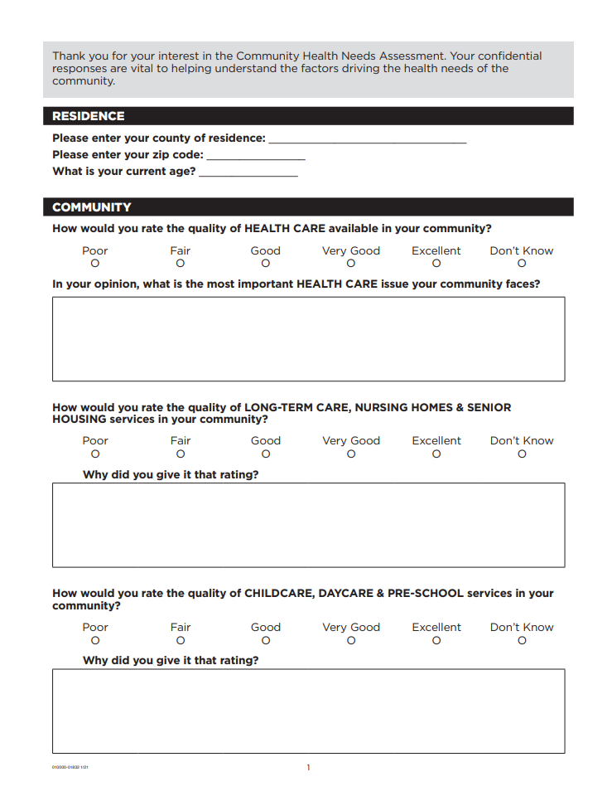

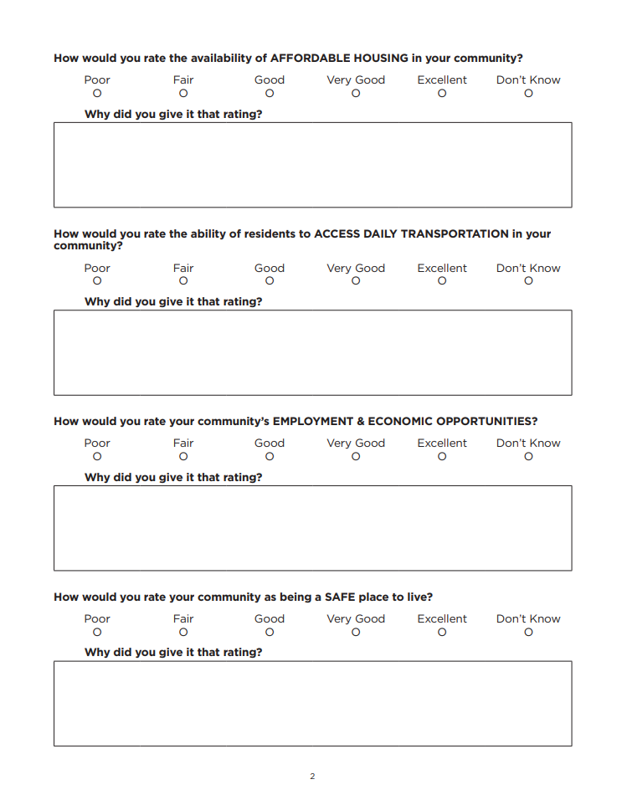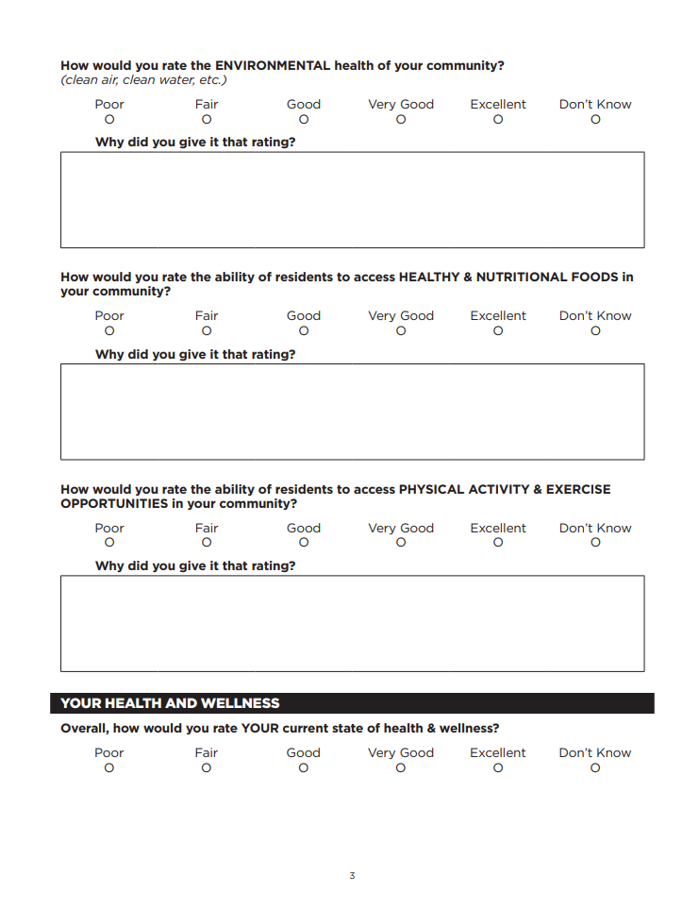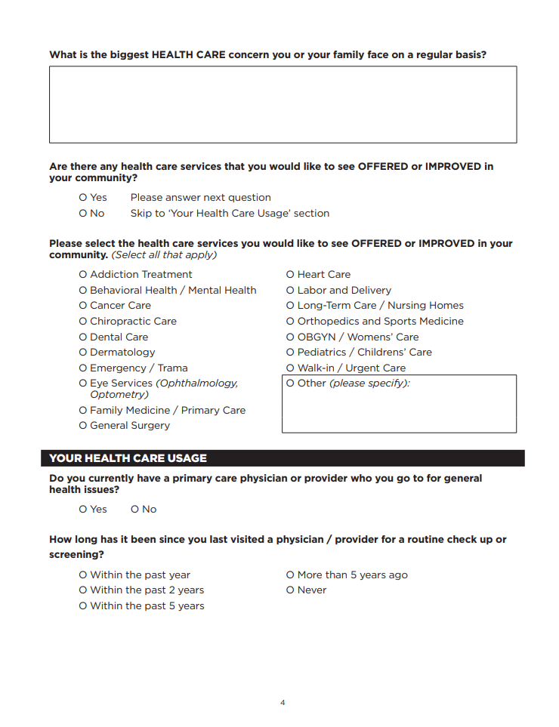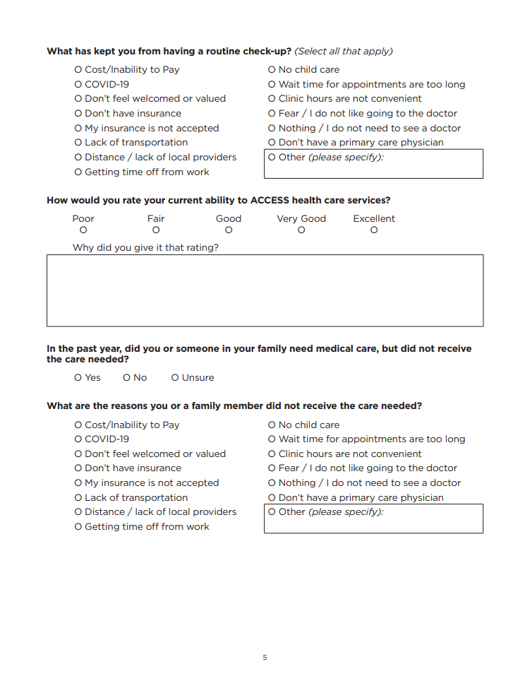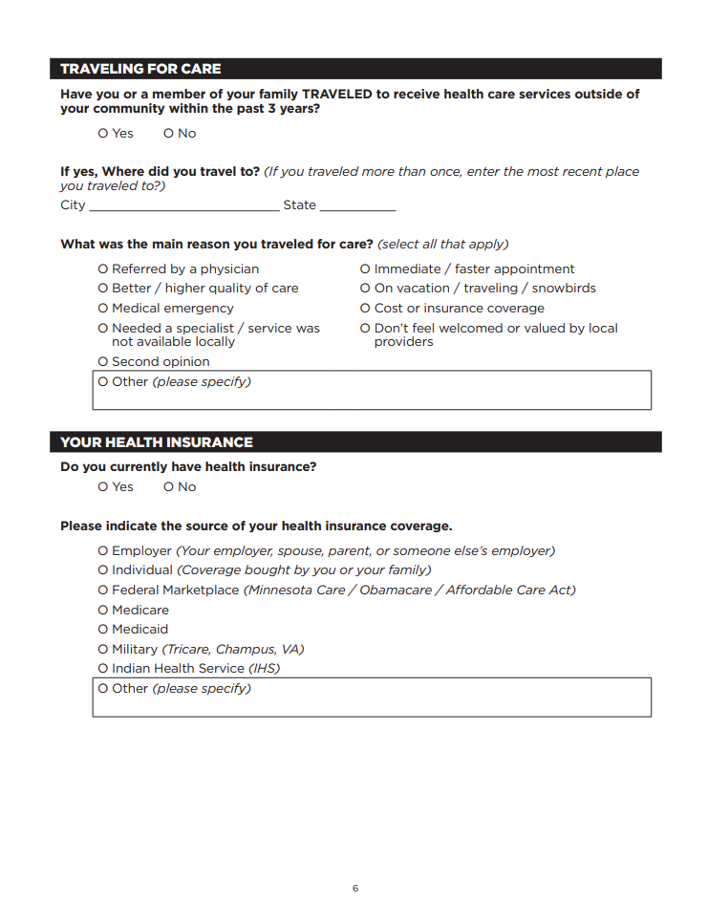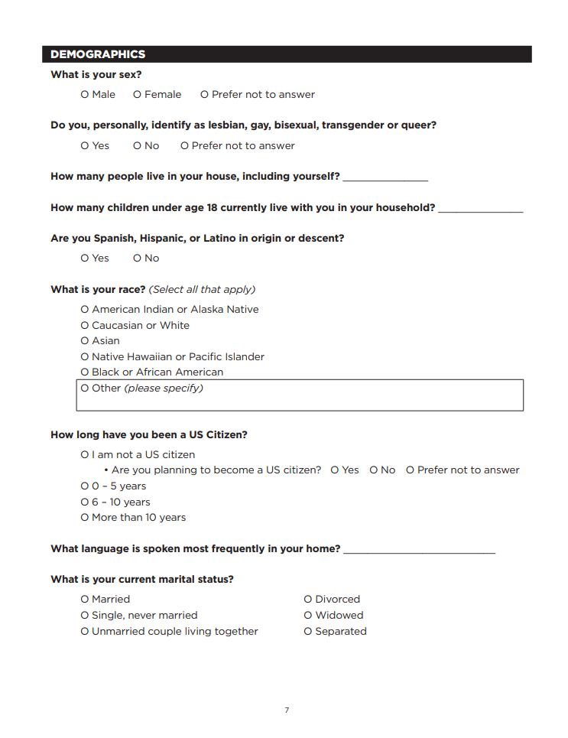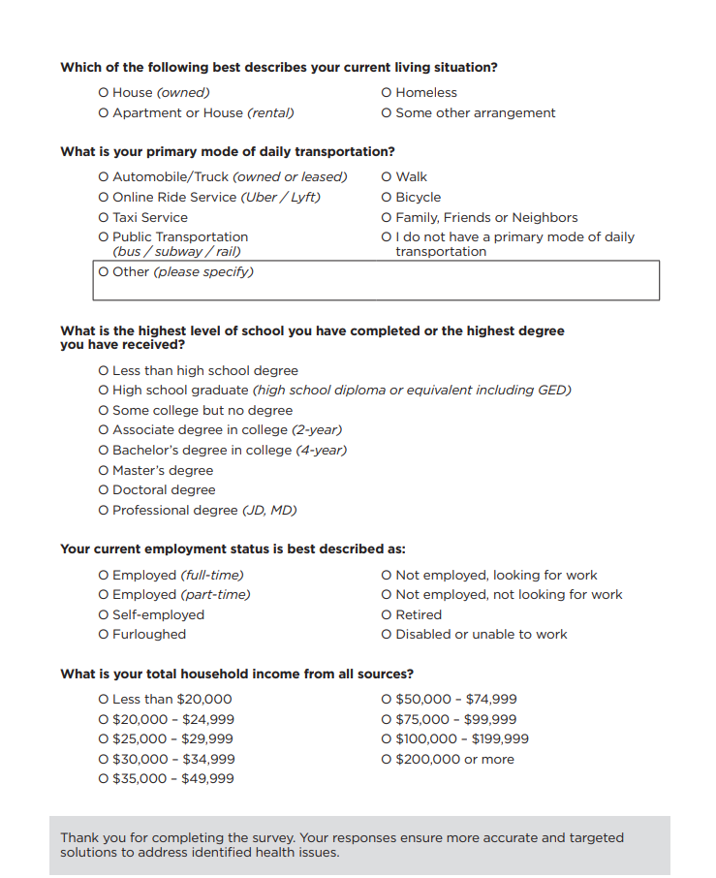

University of Wisconsin Population Health Institute. County Health Rankings & Roadmaps. Available at https://countyhealthrankings.org
Bovbjerg, R. R., & Hadley, J. (2007). Health Policy Briefs: Why Health Insurance is Important. Available at The Urban Institute, https://www.urban.org/research/publication/why-health-insurance-important
U.S. Department of Health and Human Services. Centers for Disease Control and Prevention. Improving Health Through Transportation Policy. Available at https://www.cdc.gov/transportation/php/about/index.html
The Urban Institute. Housing as a Platform: Strengthening the Foundation for Well-Being. Available at https://www.urban.org/sites/default/files/publication/93606/housing-as-platform_1.pdf
U.S. Department of Health and Human Services. Office of Disease Prevention and Health Promotion. Healthy People 2030. Housing Instability. Available at https://odphp.health.gov/healthypeople/priority-areas/social-determinants-health/literature-summaries/housing-instability
https://www.census.gov/quickfacts
https://data.census.gov/table/DECENNIALPL2020.P1?q=Gregory+County,+South+Dakota
https://www.census.gov/quickfacts

